**MURDER MYSTERY**

A crime has taken place and the detective needs your help. The detective gave you the crime scene report, but you somehow lost it. You vaguely remember that the crime was a **​murder​** that occurred sometime on ​**Jan.15, 2018​** and that it took place in ​**SQL City​**. Start by retrieving the corresponding crime scene report from the police department’s database.

**Queries**

1)

SELECT *

FROM 'crime_scene_report'

where date=20180115

AND type="murder"

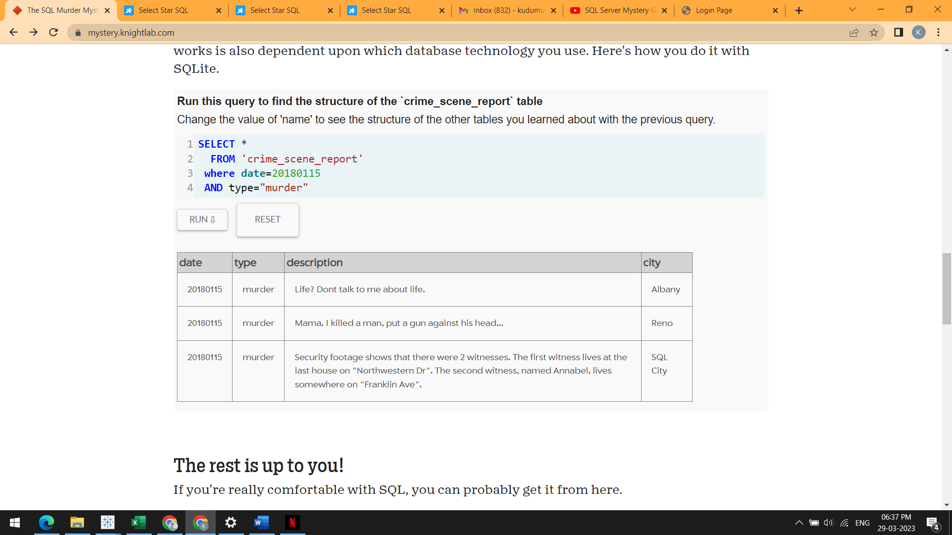

2) SELECT*

FROM person where address_street_name

like "Northwestern Dr" order by address_number DESC

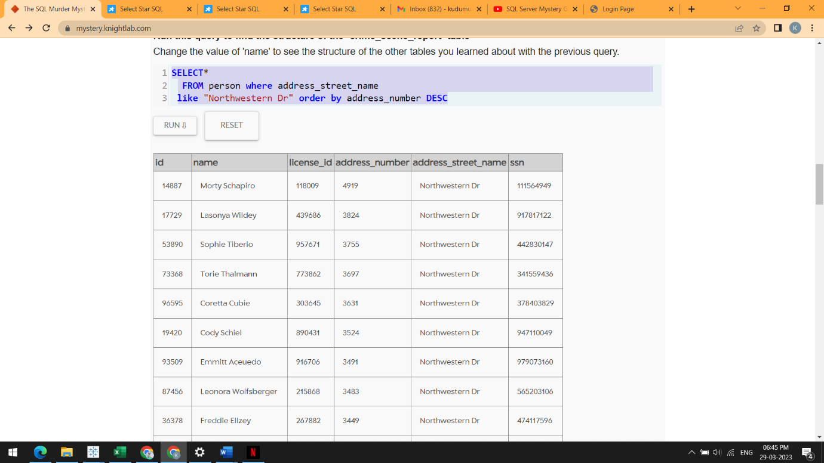

3) SELECT*

FROM person

where address_street_name like "Franklin Ave"

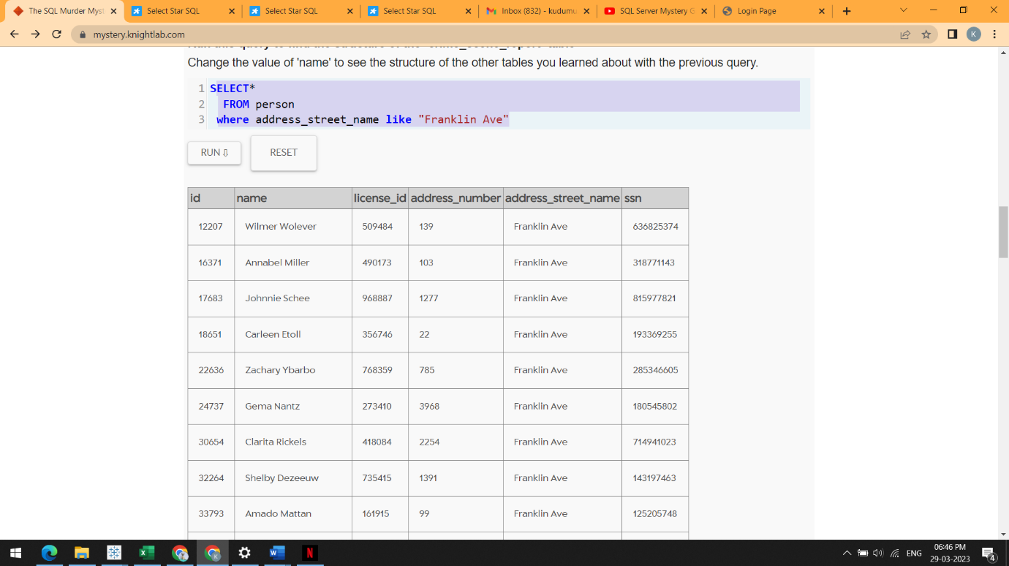

4) SELECT*

FROM interview

where person_id=14887

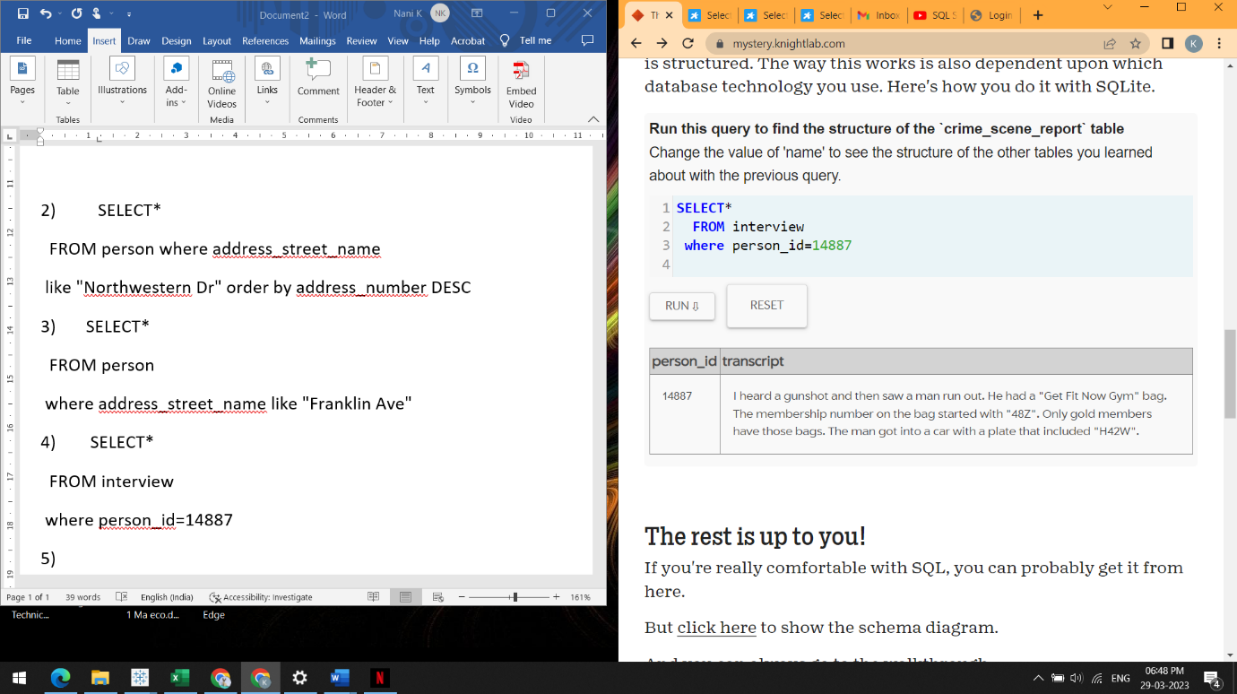

5) SELECT*

FROM interview

where person_id=16371

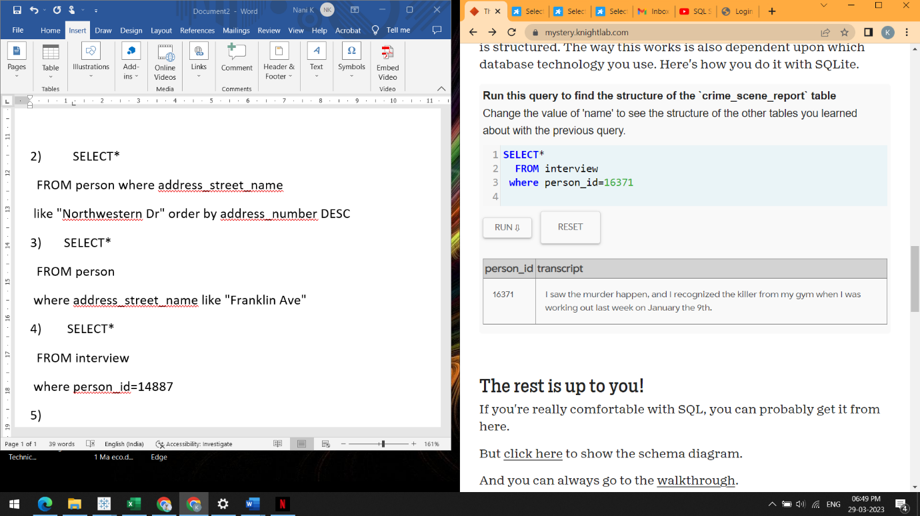

6) SELECT*

FROM get_fit_now_check_in

JOIN get_fit_now_member

ON get_fit_now_check_in.membership_id = get_fit_now_member.id

WHERE membership_id

LIKE "48z%"

AND check_in_date=20180109

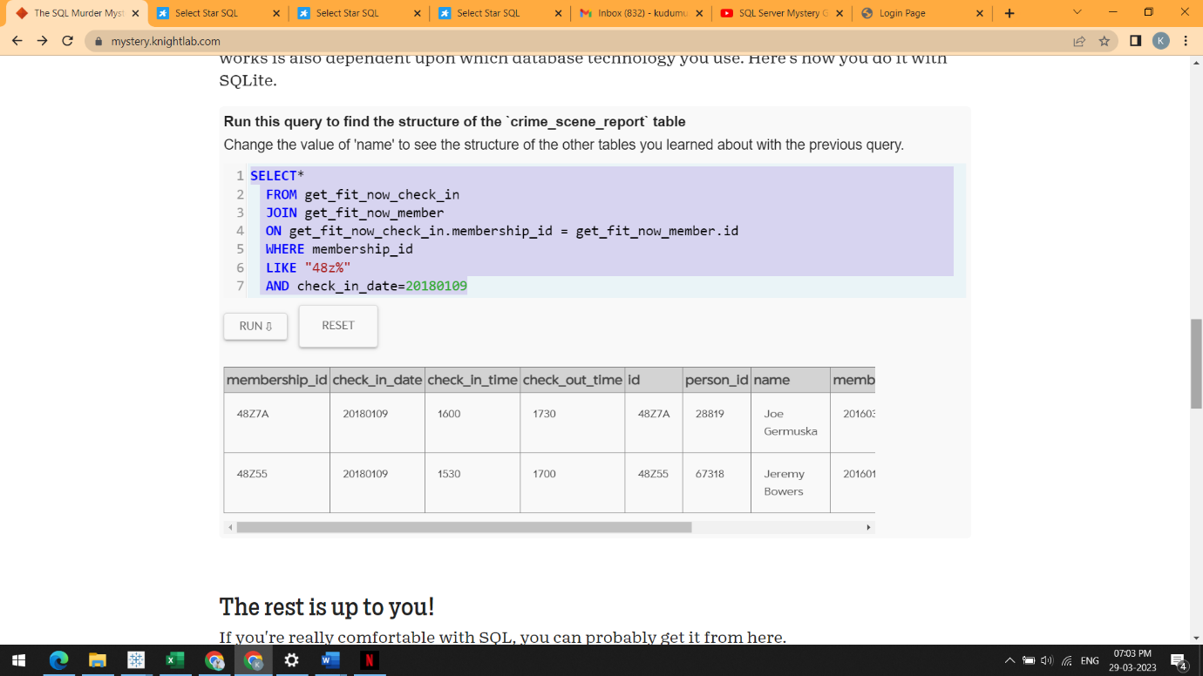

7) Insert into solution VALUES (1, 'Jeremy Bowers');

Select value from solution;

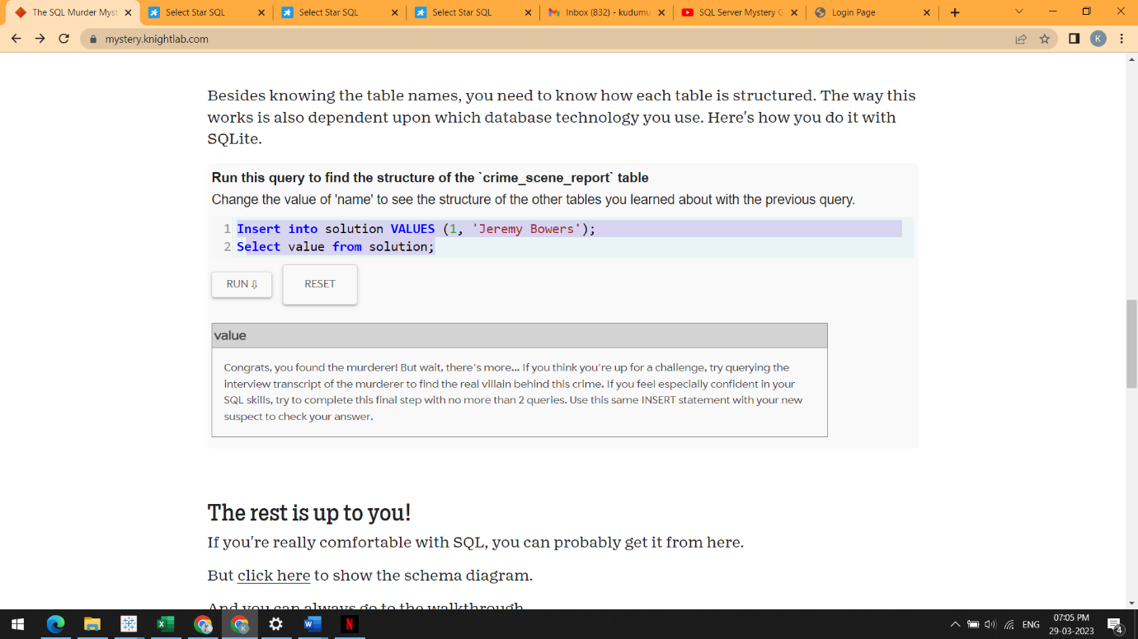

* Mystery Solved